Summer Reading for Theology
***Please note: Students cannot bring Kindles or IPads to class. They will need a hard copy for school.
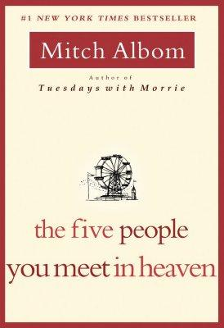
INCOMING SENIORS:
The Five People You Meet in Heaven by Mitch Albom
Be prepared for a test upon return to school in September. Email Ms. Lee-Jeter with any questions: vleejeter@mercycte.org. You will need your own copy of the book for class.

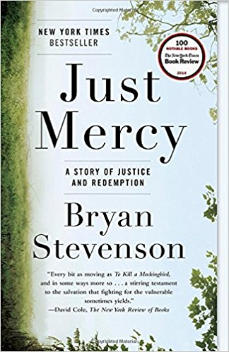
INCOMING JUNIORS:
Just Mercy by Bryan Stevenson
Be prepared for a test upon return to school in September. You can email Ms. Campellone with any questions: macampellone@mercycte.org. You will need your own copy of the book for class.

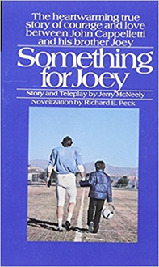
INCOMING SOPHOMORES:
Something for Joey by Richard Peck
Be prepared for a test upon return to school in September. You can email Mr. Nawn with any questions: jnawn@mercycte.org. You will need your own copy of the book for class.

INCOMING FRESHMEN:
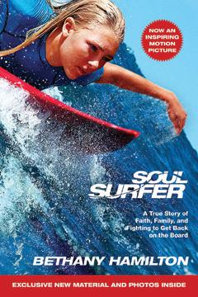
Soul Surfer: A true story of Faith, Family, and Fighting to Get Back on Board by Bethany Hamilton
Be prepared for a test upon entering school in September. Until you know who your theology teacher will be, you can email Ms. Campellone: macampellone@mercycte.org with any questions. You will need a copy of your own book for class.

