SUMMER READING FOR THEOLOGY
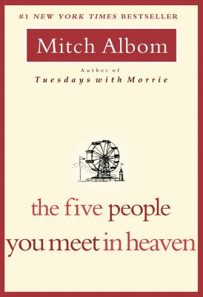
***Please note: Students cannot bring Kindles or Ipads to class. So they will need a hard copy for school.

INCOMING SENIORS:
The Five People You Meet in Heaven by Mitch Albom
Be prepared for a test upon return to school in September. Email Ms. Lee-Jeter with
any questions: vleejeter@mercyvhs.org You will need your own copy of the book
for class

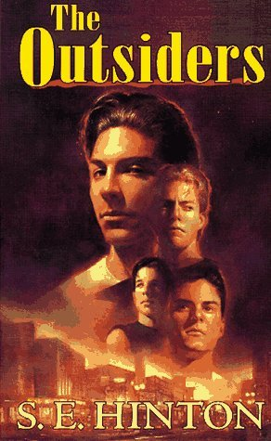

INCOMING JUNIORS:
THE OUTSIDERS by S. E. Hinton
Be prepared for a test upon return to school in September. You can email
Ms. Campellone with any questions: macampellone@mercyvhs.org . You will need your own copy of the book for class.

INCOMING SOPHOMORES:
The Lion, The Witch, and the Wardrobe by C.S. Lewis,
Book 1 of The Chronicles of Narnia
Be prepared for a test upon return to school in September. Until you know who your theology teacher will be, you can email Ms. Campellone: macampellone@mercyvhs.org with any questions. You will need your own copy of the book for class.

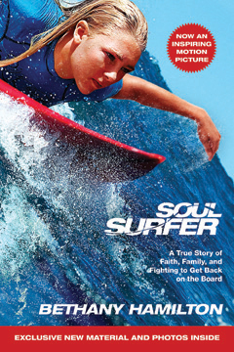
INCOMING FRESHMEN:
Soul Surfer: A true story of Faith, Family, and Fighting to Get Back on Board
By Bethany Hamilton
Be prepared for a test upon entering school in September. Until you know who your theology teacher will be, you can email Ms. Campellone: macampellone@mercyvhs.org with any questions. You will need a copy of your own book for class.

